**Project 1 : Ghost In the Machine**

**Name** :Shobhit Singh

**Net-ID**:ss4363 .

INTRODUCTION

This project is meant to highlight the difference between planning and execution - a plan may be based on incomplete information and may need to be updated or adapted as it is executed. We are going to build an environment, an agent that interacts with that environment in order to accomplish a goal and collect data to analyze the performance of the agents in pursuit of that goal.

CHOICE OF SEARCH ALGORITHM

While we do have a lot of search algorithm that can find a path in a maze, we must choose the one best suited for our case. Two things to consider when deciding on a search algorithm is:

1. The cost of moving from one cell to another is 1(constant). Not to mention, always positive.
2. The ghost’s movement in equally random. Basically, we say can that in in 20 movement, the ghost will move up,down,right,left nearly equal number of times this not moving away from the initial position. This cannot be guaranteed for larger number of movements.

In conclusion, we can reject BFS and Dijkstra algorithm as we don’t need to consider movements that move away from the goal because the cost is positive and constant, we can guarantee that it’s not going to get better after some moves.

While DFS will find a path faster and check less number of cells, it doesn’t provide the shortest path which in theory should provide a better solution less number of movements means ghosts location are predictable (as per point 2).

Thus, for this project, we choose A* search algorithm, which gives the shortest path (unlike BFS and DFS) and also does so in less searches than Dijkstra. A* is usually better when we have knowledge of the end goal and can compute a heuristic which in our case, we can.

MAZE GENERATION

The environment for this problem is a maze-like square grid. Some of the cells are open (unblocked) and some are obstructed (blocked). An agent in the environment can move among and occupy the unblocked cells but cannot enter the blocked cells. We need to create a 51 x 51 square grid, iterate through each cell, and with probability 0.28 make it blocked, with probability 0.72 make it unblocked.

To generate this maze, lets first write a function that returns True or False with a probability of 72:28 as in the picture below:

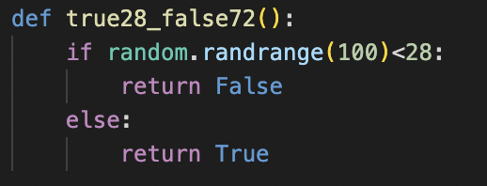

This function generates a random value from 0 to 99 and then returns False if the value is below 28 and True if the value is above 27. For large number of data, this maintains the 28:72 ratio.

Now, to make a maze, we will define a 2D matrix of dimension 53*53 and traverse through it, assigning them as blocked or unblocked using the probability of the above function “true28_false72”. The code for the matrix creation can be found below.

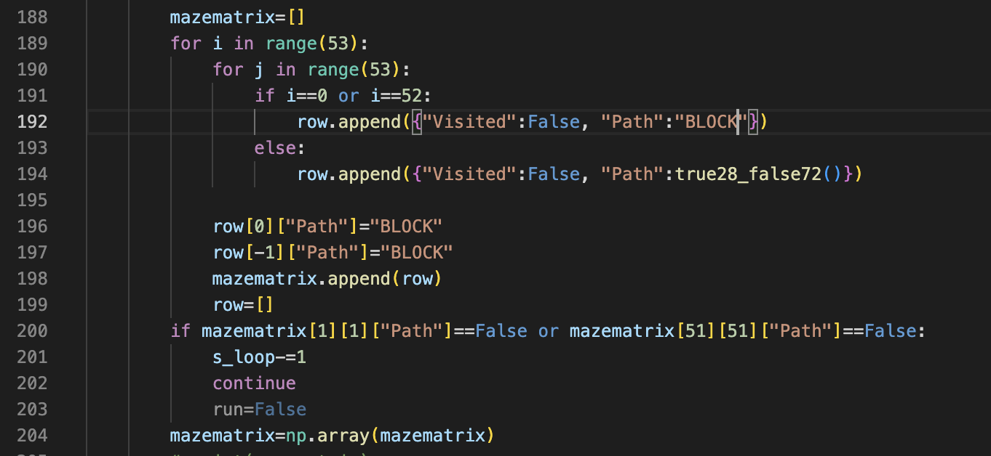

Note that each cell has a Visited argument which is used for visualization, a Path argument which tells if it is a Blocked cell or Open. The Path key can be True, False or BLOCK. The outer layer of this 53*53 has been assigned as “BLOCK” making the effective dimension as the required 51*51 matrix. This is an easy solution to the index out of bound error when finding neighbors of a cell.

Once the MAZE has been generated randomly, we need to check if the start (1,1) position and end (51,51) positions are not blocked. If it is blocked, we decrement the while loop iterator (s_loop) and rerun the simulation till it creates a valid Maze. While we could just make (1,1) and (51,51) True by hardcoding the values, it’s not fun and might slightly topple the 28:72 ratio.

*Note: BLOCK and False differ as ghosts can enter False cells but not BLOCK cells.*

CHECKING A PROPER PATH IN THE MAZE

To check if a proper path exists, we use the following code:

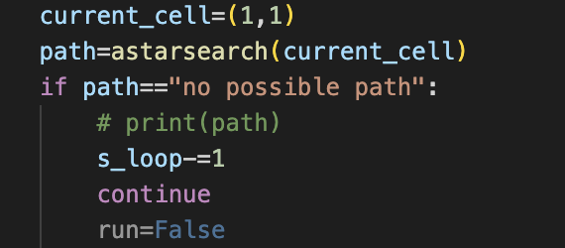

The function astarsearch(<tupple>) returns a path(if it exist) from the passed position to (51,51). If a path doesn’t exist, it returns “no possible path” in which case, we decrement the iterator(s_loop) and retry the simulation with a new Maze. We will talk about the astarsearch function in detail later.

Note: since ghosts haven’t been added yet, it finds a path in the maze without ghosts, which is what we want as ghosts will move to create a path with time. Just because it’s blocking the path right now doesn’t mean the maze is bad. So, we do this test without ghosts.

GHOST CREATION

To create ghosts, we will define an array with all the unblocked cells and choose from this array randomly n number of times (where n is the number of ghosts).

It is completely fine if 2 ghosts spawn at the same cell as they will still exist as 2 entry and move randomly independent to one another.

Note: I have assumed that while ghosts can move through walls, they cannot spawn on walls or else there would be no point in checking if all ghosts can reach the player in the next section as stated in the problem statement. However, this can be done easily by taking all cells and not just unblocked cells.

The below code creates ghosts following the above description:

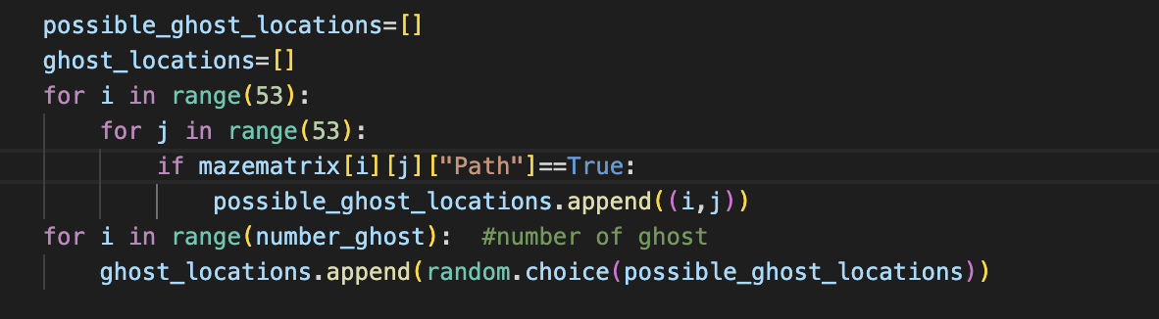

The nested loop stores all unlocked cell in the possible_ghost_locations list variable. The last loop runs number_ghost times selecting and storing that many ghosts in the ghost_locations list. This list will be used to update the location and identify if the ghost present in a cell or not. There is no flag for ghost in the matrix cell directly.

CHECKING FOR VALID GHOST SPAWN

Each ghost starts at a random location in the maze that is reachable from the upper left corner (so that no ghost gets walled off). To achieve this, we can reuse our astarsearch function to find if there exists a path between the ghost location and (51,51). Since we already checked that (51,51) is reachable from (1,1), this would mean ghosts can reach (1,1).

We write the following code to achieve this:

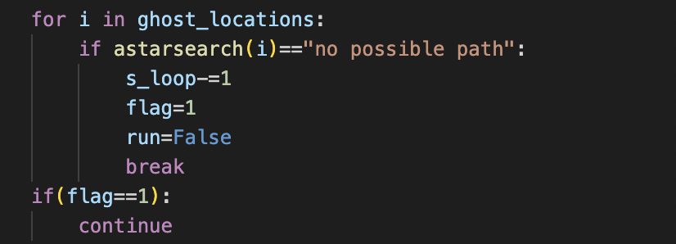

If any ghost is not reachable from (1,1), the iterator is decremented, loop breaks and the while loop is rerun.

GHOST MOVEMENT

at every timestep, a ghost picks one of its neighbors (up/down/left/right);if the picked neighbor is unblocked, the ghost moves to that cell; if the picked neighbor is blocked, the ghost either stays in place with probability 0.5, or moves into the blocked cell with probability 0.5. (These rules apply even if the ghost is currently within a blocked cell.)

To achieve this, we use the following function:

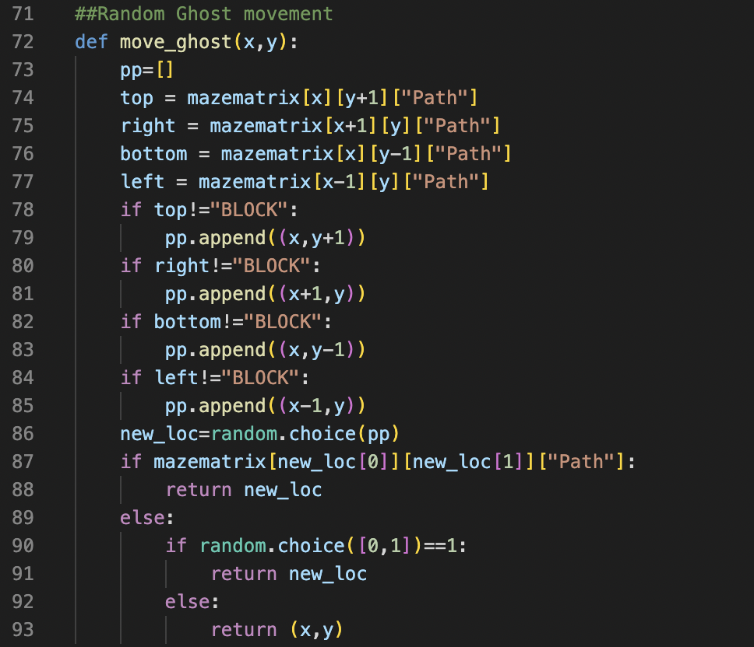

The function takes the x,y coordinate of a ghost and finds all 4 of it’s neighboring cell. It appends the neighbors that are not “BLOCK” (as we don’t want the ghosts to move outside the 51*51 dimension) and appends them to the pp list. It then randomly selects one of the neighbors and stored the position in the variable “new_loc”. If the new_loc cell is unblocked, it returns it which becomes the new location of the ghost (line 88). If the new_loc is a closed cell, it returns new_loc with a probability of 50% or else returns the original position.

ASTAR SEARCH ALGORITHM

Before we get to agents, Lets understand the astarsearch() function that we are going to use:

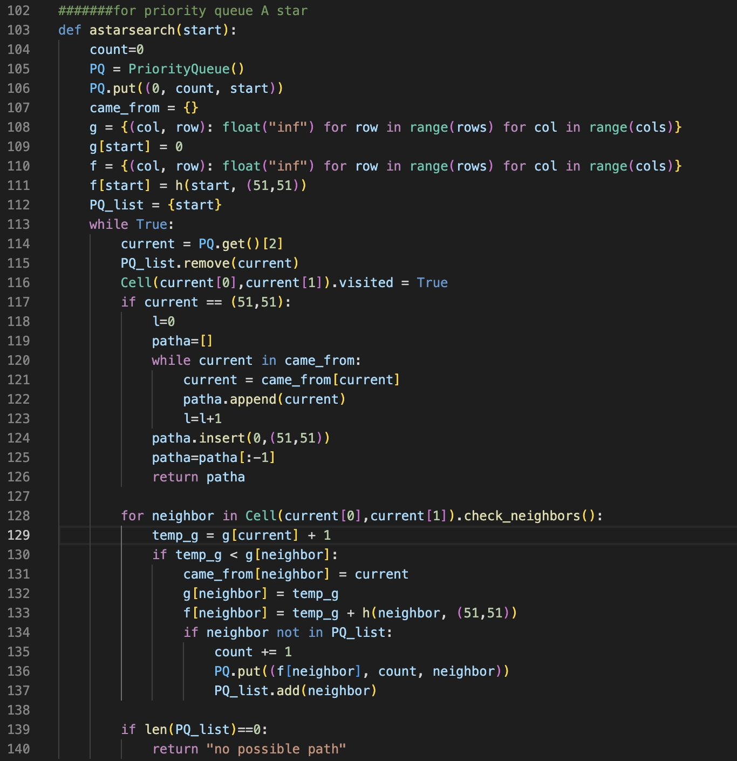

This is a simple A* search algorithm that we will use to find the shortest path from a start node to (51,51). The loop runs infinitely with 2 exit condition. One, when the current node is same as (51,51) (i.e. a successful path found) or the priority queue is empty so there is no possible path.

*The function returns the path if possible or else returns “no possible path”.*

WHEN DOES THE AGENT DIES

* **Case 1**: The agent dies when it runs into the ghosts.
* **Case 2**: When the ghost is next to a cell the agent moves to and comes in at the same time the agent enters the cell.

AGENT 1

Agent one simply finds the best(shortest) path in that maze and traverses through it. It disregards the ghost’s existence and simply follows the path. The following code, implements Agent 1

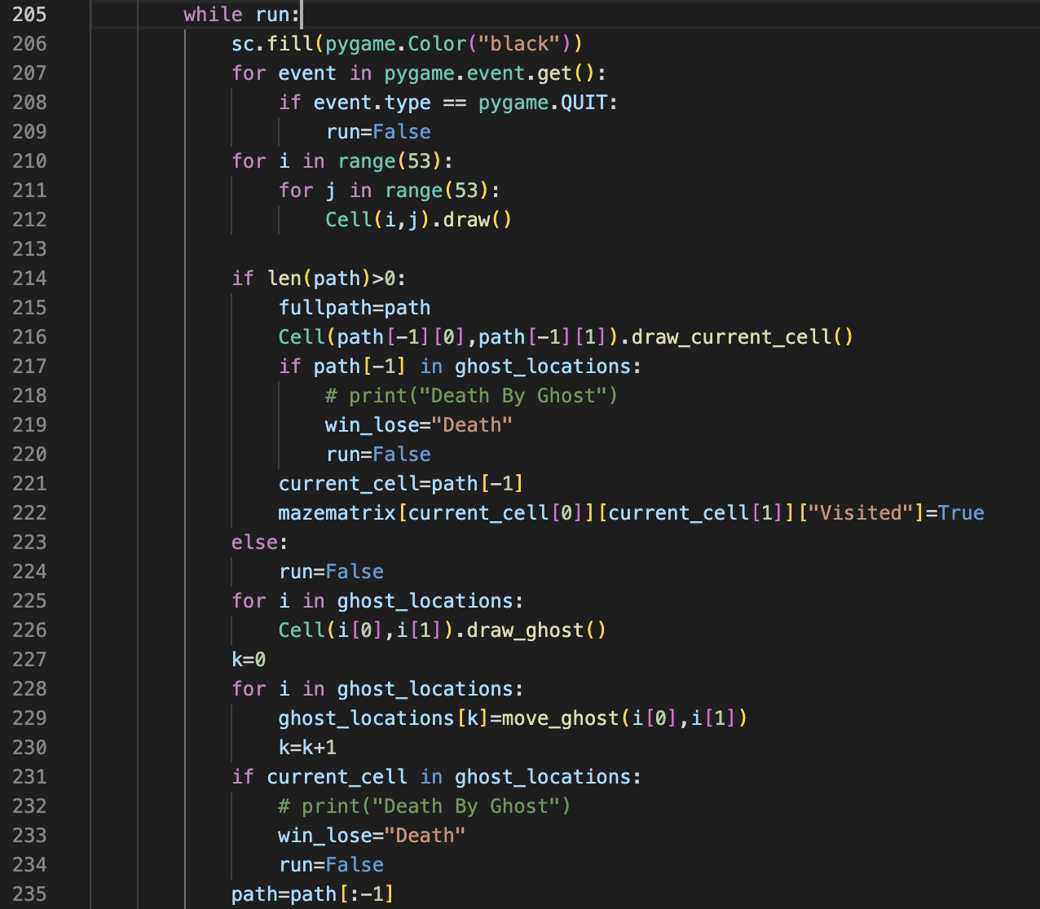

In the code above, before entering the while loop, the path variable already has the A* path stored in it. The agent’s current cell is set to the last value of the path (note that the path variable stores the A* path in reverse) in line 221. Every time, the current cell is reduced from the path in line 235 without replanning forcing the agent to follow the initial path even if ghosts are in front. While the agent does ignore the ghosts when planning, the ghosts doesn’t ignore the agent. We are still simulating the ghosts and if it crosses path with the agent, the agent dies

AGENT 1 SIMULATION



AGENT 1 GRAPH

Agent 1 was tested 2000 times incrementing ghosts by 5 from 5-200. For each level of ghost, it ran 50 times. The below graph shows its performance at each level/number of ghosts.

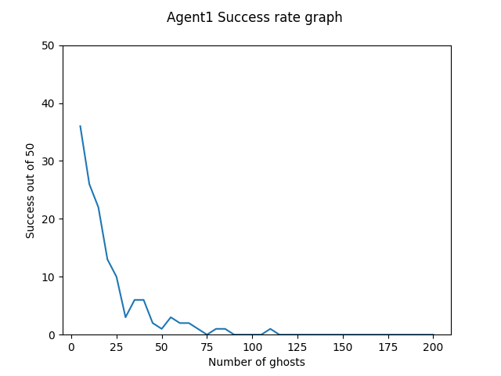

The success rate goes to 0 at 90 ghosts and crossed the maze 136 out of 2000 times

AGENT 2

To reduce the deaths from case 1 of death above, we replan the path each time. To achieve this, instead of removing current cell from the path, we replan the entire path from that current cell. The for the same is below.

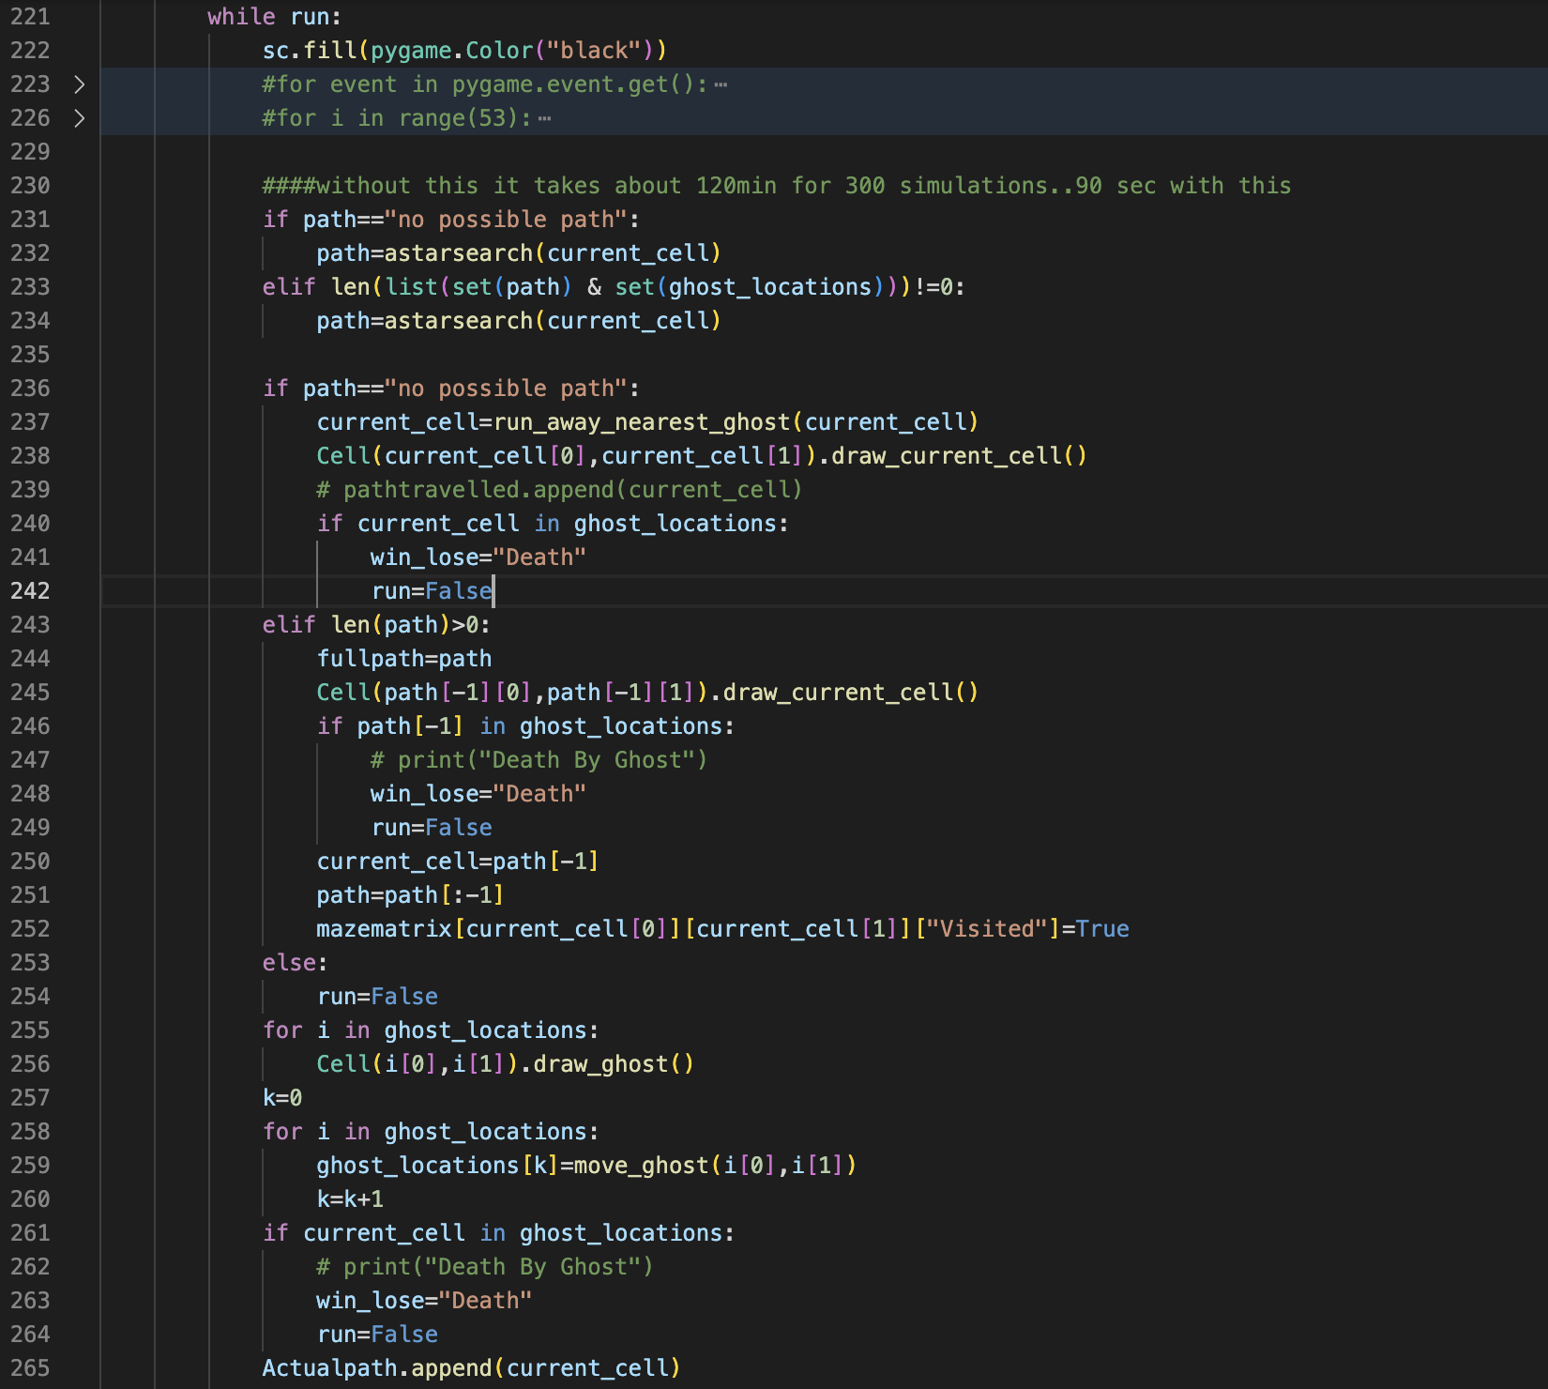

In the above code, line 233 and 234 gets the new path from the current cell location.

**Q.) Do you always need to replan? When will the new plan be the same as the old plan, and as such you won’t need to recalculate?**

*It should be noted that to minimize the total computation of the algorithm, we only replan the path if a ghost is in the path or, the ghosts completely blocked any possible path to the end (51,51). If no ghost obstructs the path, the agent follows the same unobstructed path without replanning (line 251). Line 233 checks for a new plan if there is an intersection between ghost location cells and path cells.*

*Also, we can also approach it as don’t change the path until a ghost is nearby (imminent threat). This has been implemented in Agent 4 as that algorithm facilitates this implementation*

If the agent replans and finds that the ghosts have blocked all path to the goal, It calls the function “run_away_nearest_ghosts” and finds the closest closest ghost and moves away from it before replanning to check if a path exits at next interval of time. The below code achieves this functionality:

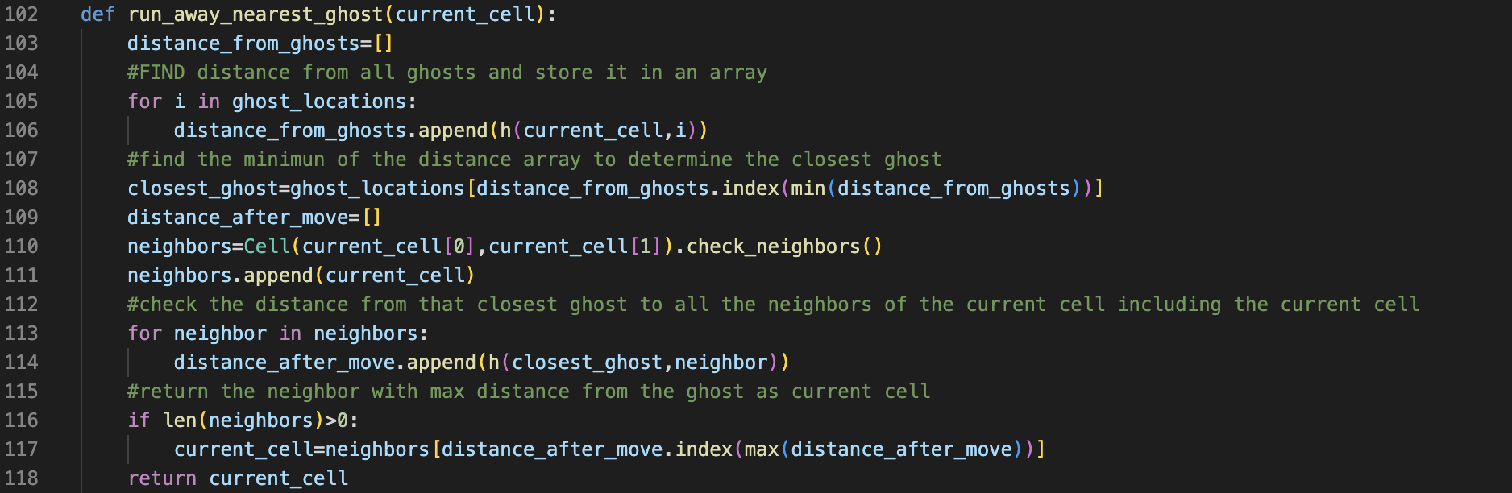

*Note: to find the nearest ghost, we can easily change from taking Manhattan distance to A* distance by calling astarsearch() instead of h() in line 106. However, I feel Manhattan distance is more accurate since the ghosts can travel through walls and come to ghost. A* finds the shortest distance considering traversing through wall is not possible in our case. If we write another A* function considering travelling through walls is possible, it will always be same as Manhattan distance anyway.*

AGENT 2 SIMULATION



AGENT 2 GRAPH

Agent 2 was tested 2000 times incrementing ghosts by 5 from 5-200. For each level of ghost, it ran 50 times. The below graph shows its performance at each level/number of ghosts.

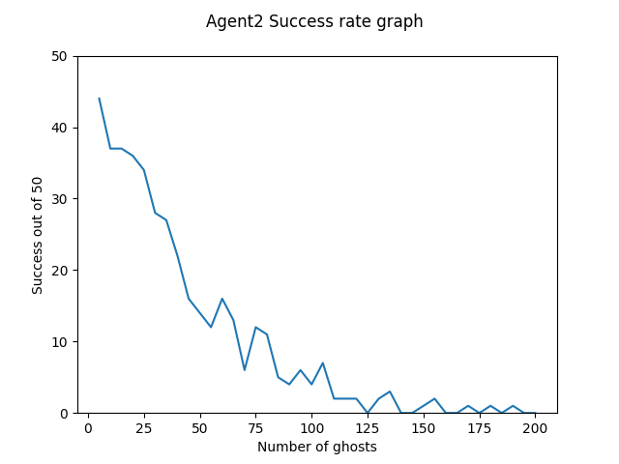

The success rate goes to 0 at 160 ghosts and crossed the maze 408 out of 2000 times

AGENT 3

Agent 2 plans the future based on the success rate of agent 2. At each location, it checks how many times agent survives from its adjacent neighbor and its current position (line 295) as well to incorporate staying in place and goes to where the survivability is best.

**Tie breaker for equal success rate:**

While in theory, success rate should give a better estimate of which neighbor to go to, since agent 2 itself is simulated from adjacent cells (not very far from each other), the success rate is almost always similar. This results in back and forth motion.

To solve this, we add priority for each neighbor making it so unless the difference in success rate is marginal, the agent prioritizes moving towards the cell closer to the goal.

We reduce the success rate of cells farther from goal by 15% and if there are still similar success rate after this reduction the algo chooses from the ones with less distance.

Note: When I say prioritizes moving towards the cell closer to the goal, I am taking about A* distance. I did test it with planned distance and coded to enable it(as you will see in run_agent2() function), but I opted out of it since it was not solving the uncertainty problem as just like success rate, planned path length is also uncertain.

The below code achieves the same:

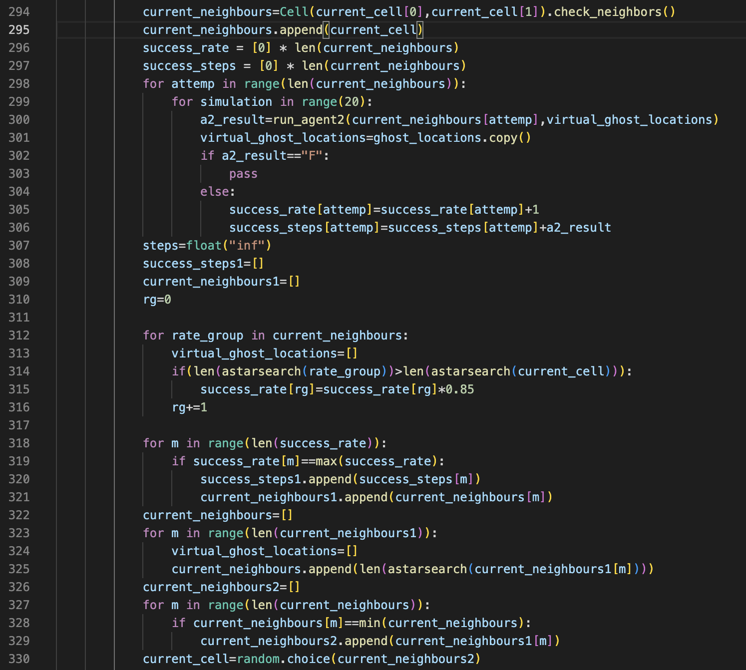

The code file is well commented. Just removed here to fit the code in one frame.

We also need to write an agent2 function to run the entire agent 2 simulation every time we need it. These simulations will run based on ghost moment that needs to be separate from the original ghost location. The following code snippet shows that run_agent2 function:

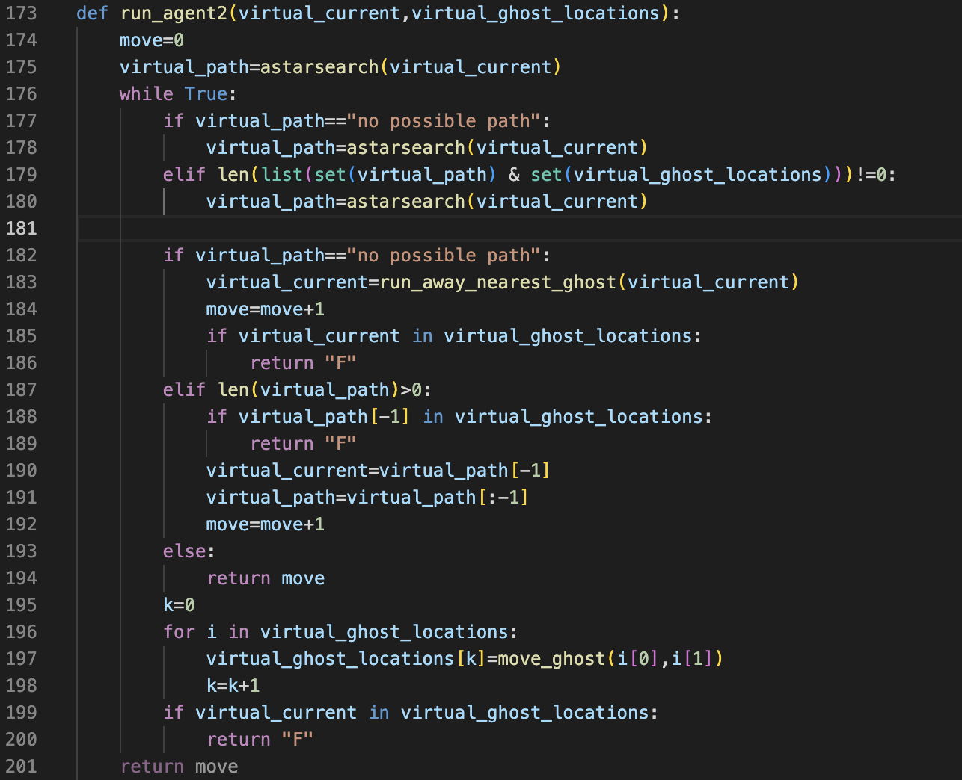

The above code is like agent2 and returns “F” if it fails and no. of moves it takes to reach the goal if it succeeds. The moves variable can be used to set priority on the neighbors.

*Note: For out algorithm, a true and false value would have been sufficient, but I was trying to prioritize the selection based on the node that takes the least average steps to succeed. It didn’t solve the to and fro motion, so I chose to consider A\**

**Q.) you’ll want to ensure that your searches are efficient as possible, so they don’t take much time. Additionally, if Agent 3 decides there is no successful path in its projected future, what should it do with that information? Does it guarantee that success is impossible?**

We have already optimized Agent 2 not plan at each interval. Since this makes the simulations faster, Agent 3 also becomes faster. We still need to run Agent 3 at every step as otherwise it will be too similar to Agent 2.

If Agent 3 decides that there are not successful path from any of the neighbor and current cell(i.e success rate is 0 for all), It will just randomly choose a cell among them as it doesn’t make a difference. If the Agent 3 is correct about having no successful path, it will die.

*Note: Skipping simulation GIF as agent is too slow to attach GIF.*

AGENT 3 GRAPH

Agent 3 was tested 110 times incrementing ghosts by 5 from 5-40 and then by 20 up to 100. For each level of ghost, it ran 10 times, and the result was multiplied by 5 to maintain consistency over all agents. The below graph shows its performance at each level/number of ghosts.

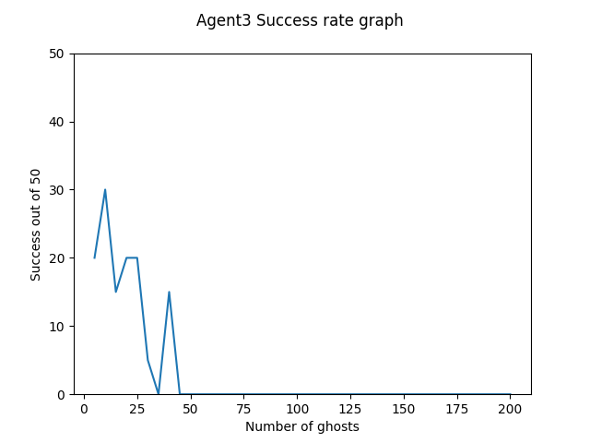

The success rate goes to 0 at 45 ghosts and crossed the maze 125 out of 2000 times.

AGENT 4

While Agent 2 somewhat solves the case 1 of why agent 1 failed, but to address the case 2, we need to make sure the agent avoids going to any neighbor cell if ghost locations as well, so it doesn’t get ambushed when ghost moves next. To achieve this, we make a path avoiding all ghost’s neighboring cell as well. The below code sends all cells to avoids for a given ghost locations.

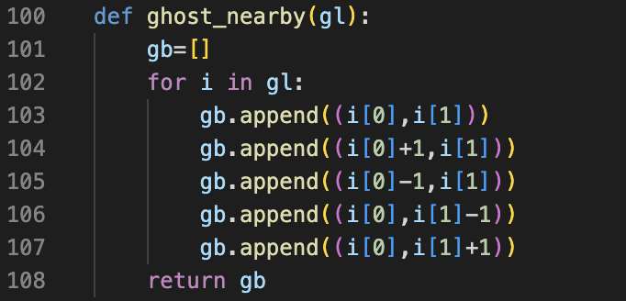

So, if we find neighbors of current cell using these locations instead of just the ghost’s location, we solve the death case 2 as well.

Also, to make the complexity of Agent 4 low, we slightly update the condition when we replan the path. Instead of replanning when a ghost is in the path, we add another condition that the ghost also needs to be closer to the agent as well. It is possible that ghosts just move by the time agent gets near it. So, swaying from the path was previously useless.

To do this, we reuse the ghost_nearby function to find if any cells from the restricted cell overlaps with the current cell neighbors using the below code.



**When Agent 4 dies**:

Agent 4 avoids all cells that might lead to its death after 1 move as well. Since this is true for every move, it makes sure that it is always safe until it’s next move. But what if it gets cornered? If it so happens that it gets surrounded by ghosts and cannot go to a place that guarantees safety until next move, it dies. A simple example would be if it tries to cross a walled off narrow path and 2 ghosts enter from both ends.

AGENT 4 SIMULATION



AGENT 4 GRAPH

Agent 4 was tested 2000 times incrementing ghosts by 5 from 5-200. For each level of ghost, it ran 50 times. The below graph shows its performance at each level/number of ghosts.

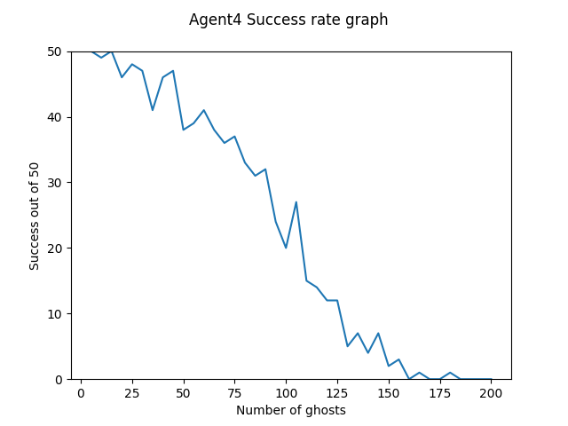

The success rate goes **to 0 at 185 ghosts** and crossed the maze 903 out of 2000 times

COMPARING ALL 4 AGENTS

The graph below, overlaps all agent results so they are easier to compare.

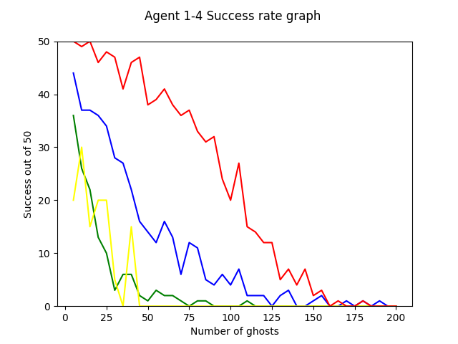

|  |  |  |  |  |
| --- | --- | --- | --- | --- |
| **AGENT NUMBER** | **COLOR** | **Reached 0 success rate** | **TOTAL Success (/2000)** | **Time Taken for simulations(min)** |
| **AGENT 1** | Green | 90 | 136 | 15min |
| **AGENT 2** | Blue | 160 | 408 | 18min |
| **AGENT 3** | Yellow | 45 | 125 | 534min (for 120 runs) |
| **AGENT 4** | Red | 185 | 903 | 74min |

Agent 3 should perform better than Agent 1 but we ran Agent 3 for 120 simulations and scaled up while Agent 1 was run for 2000 simulations.

**Why Agent 3 performs worse than Agent 2:**

Agent 2 simply calculates the shortest path avoiding the ghosts. The performance of agent 3 is totally dependent on how well it can predict the future. However, it checks future for adjacent cells, and they are too close to each other. So, the start point of neighbors are effectively the same. Since the Agent that simulates (Agent 2) is same and the number of ghosts in between is the same, doesn’t matter if you simulate from (1,1) or (1,2), the success rate will be same. As such, the success rate similar for all cells closer to the agent. To break the tie we are forced to prioritize closer cell which in most case, is down or right.

So, Agent 3 is effectively going down and right (unless they are blocked) to reach the destination. So, it performs so poorly.

**Why Agent 4 performs best?**

Agent 4 takes care of both Death cases. It avoids running into ghosts and doesn’t go an adjacent cell of any ghost in general. Agent 2 only avoids case 1 of death and Agent 1 doesn’t avoid anything. So, Agent 4 performs best. Agent 4 still dies when it gets cornered (explained in detail in agent 4 section).

THE AGENT 5 SCENARIO

Up until now, we had full information of all ghost location. Now we consider what happens if we cannot see the ghosts that move inside the wall.

**Agent 1**: Will not be affected as it was not considering any ghost location in the first place.

**Agent 2**: Will not be affected as well. This is because, it only plans and replan when the ghost obstructs its path. When the ghost is in the wall, it does not obstruct the path and need not be considered anyway. So, it doesn’t affect the algorithms success rate.

**Agent 3**: Will not be affected as it predicts based on agent 2 and since agent 2 is unaffected by this scenario, agent 3 is also unaffected.

**Agent 4**: does take into consideration the surrounding cells of the neighbor even if the ghost is inside the wall and avoids them thus being safe for any surprise attacks from inside the wall. However, for this scenario, since it cannot avoid the neighbor cells of invisible ghosts, it can go there and die when the ghost comes out.

To check the effect of this scenario on Agent 4, me make a small adjustment in out. In our ghost_location array, we store ghost locations as tuple for ghosts visible and as list for ghosts inside wall. We can now determine which ghost is invisible by the datatype and since both tuple and list syntax is same, we don’t need to make drastic changes.



We still need to move the ghosts normally but only plan path based on tuple ghost location. So, we make another array that stores all visible ghost locations and avoids only these locations.

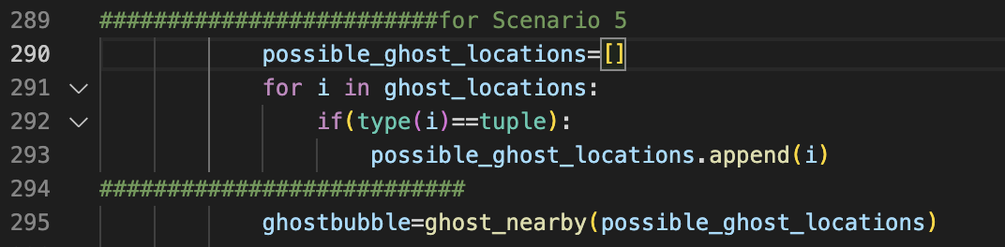

This enables us to test invisible ghost scenario.

AGENT 4(with invisible ghost) GRAPH

Agent 4 was tested 2000 times incrementing ghosts by 5 from 5-200. For each level of ghost, it ran 50 times. The below graph shows its performance at each level/number of ghosts.

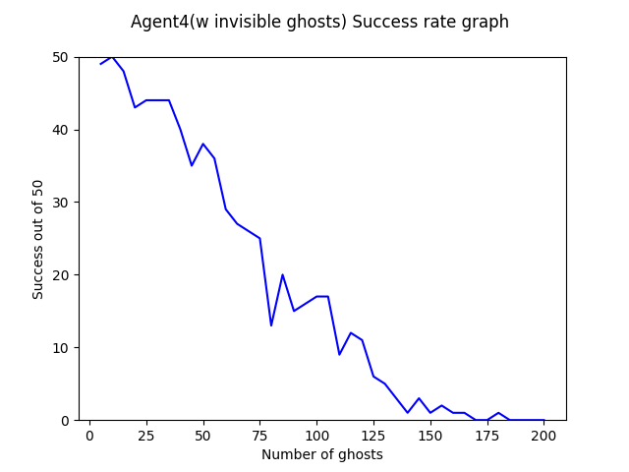

The success rate goes to 0 at 185 ghosts and crossed the maze 732 out of 2000 times

AGENT 5

To avoid ghosts ambushing us from the wall, we need to predict if the ghost is in the walls of an area and avoid that area. Since we have is the last known location of a ghost that became invisible, we can assume that assume that the ghost is in nearby wall. We will now update our Agent 4 to avoid this last known ghost location in case the ghost enters the wall.

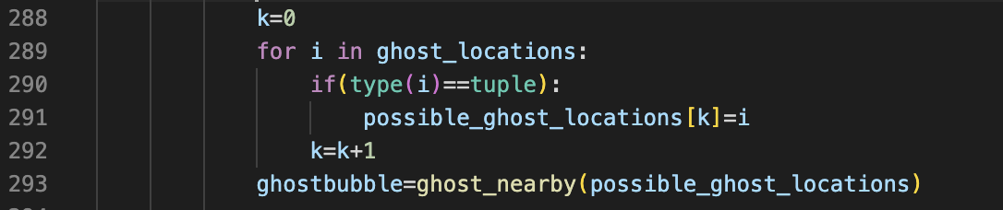

In this case, instead of only adding the ghost location if it’s visible, we only update the ghosts that are visible and let the last location of a now invisible ghost (a list datatype) stay in the possible_ghost_locations list to be avoided.

Of course, it is possible (however less likely) that the ghost enters a wall and traverses through the walls only for a long time and reaches next to the agent. This is a scenario, apart from being cornered, that agent 5 dies. So, for a large number of simulations, Agent 5 will perform better than Agent 4 for this scenario.

AGENT 5 SIMULATION



AGENT 5 GRAPH

Agent 4 was tested 2000 times incrementing ghosts by 5 from 5-200. For each level of ghost, it ran 50 times. The below graph shows its performance at each level/number of ghosts.

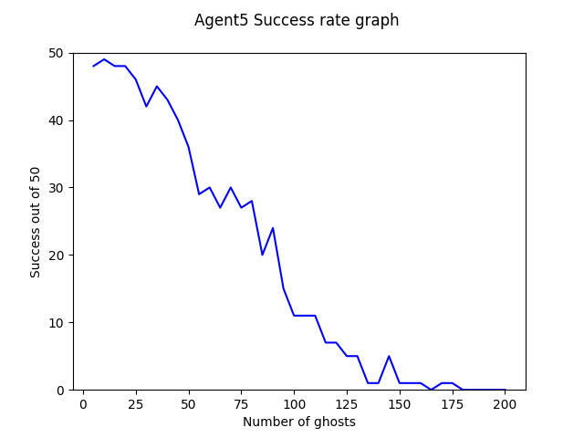

The success rate goes to 0 at 180 ghosts and crossed the maze 744 out of 2000 times

Agent 4 succeeds 732 number of times for this scenario. This gap will only increase as we take a greater number of simulations. So, Agent 5 is better for this case.